35.17: Bright fringes for wavelength are located by 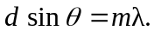 First-order 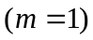 is closest to the central bright line, so 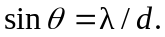
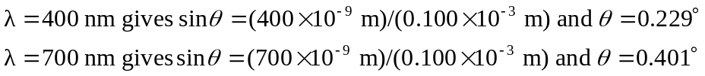
The angular width of the visible spectrum is thus 